StartAhb CRM — Project Workflow Documentation
Version: 1.0

1. Architecture Overview
StartAhb CRM is a microservices-based enterprise CRM platform built with Spring Boot (backend) and Angular (frontend). The system follows a service-oriented architecture using Netflix Eureka for service discovery and Spring Cloud Gateway for API routing.
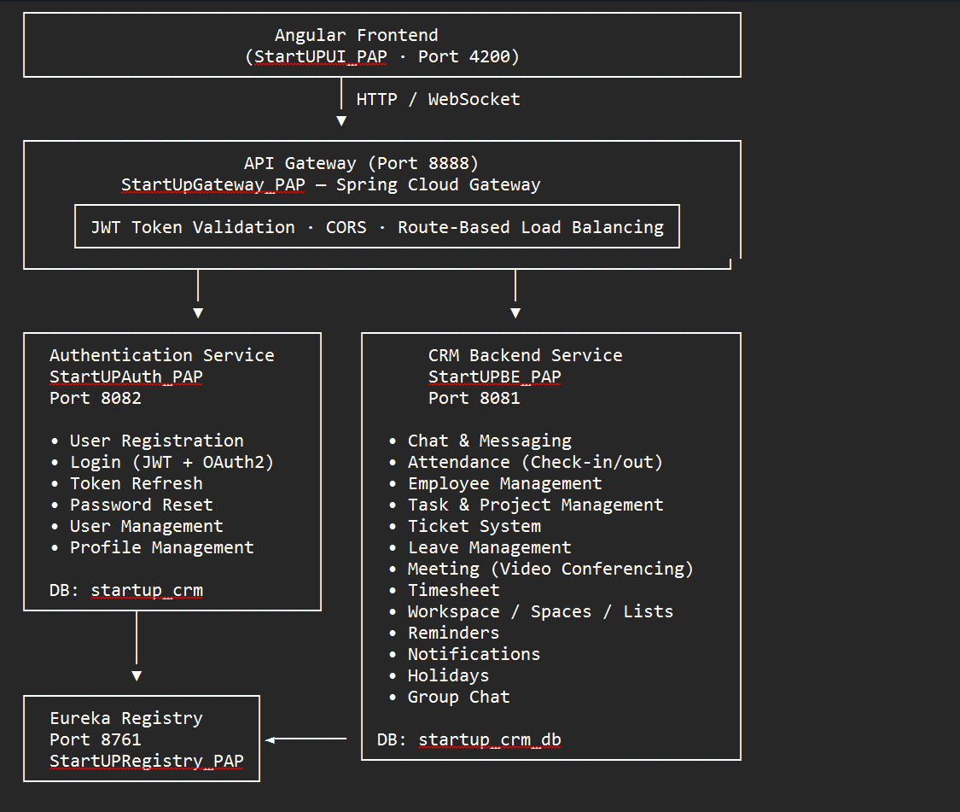

2. Technology Stack
Layer | Technology
Frontend | Angular 19, TypeScript, SCSS
API Gateway | Spring Cloud Gateway (Reactive/WebFlux), Gradle
Auth Service | Spring Boot 3.3.0, Java 21, Maven
CRM Backend | Spring Boot 3.3.0, Java 17, Maven
Registry | Spring Cloud Netflix Eureka Server, Gradle
Database | MySQL (with JPA/Hibernate)
Auth | JWT (jjwt 0.11.5), OAuth2 (Google/Facebook/GitHub)
Messaging | WebSocket (STOMP)
IPC | OpenFeign (inter-service communication)
Email | Spring Boot Starter Mail (SMTP via Gmail)
Mapping | ModelMapper, Lombok

3. Service Registry StartUPRegistry_PAP

Central service discovery using Netflix Eureka. All microservices register themselves here, enabling dynamic routing by the API Gateway.

Property | Value
Application Name | StartUp_CRM_Service_Registry
Port | 8761
Build System | Gradle
Self-Register | false
Fetch Registry | false
Dashboard URL | http://localhost:8761

File | Description
StartUpCrmServiceRegistryApplication.java | Main application entry point
application.properties | Eureka server configuration

4. API Gateway — StartUpGateway_PAP

Spring Cloud Gateway routes incoming HTTP requests to appropriate microservices, handles JWT validation, CORS, and implements route-based load balancing.

Property | Value
Application Name | StartUp_CRM_API_Gateway
Port | 8888
Build System | Gradle
Gateway Type | Reactive (WebFlux)

- Client sends HTTP/WebSocket request to http://localhost:8888
- Gateway applies filters: JWT token validation, CORS headers
- Route-based load balancing routes request to registered service
- Service processes request and returns response
- Gateway forwards response back to client

5. Authentication Service — StartUPAuth_PAP

Handles user authentication, registration, token management, OAuth2 integration, and password reset functionality.

Property | Value
Application Name | startup-auth-service
Port | 8082
Java Version | 21
Build System | Maven
Database | startup_crm (MySQL)

Method | Endpoint | Description
POST | /auth/register | User registration with email validation
POST | /auth/login | Login with JWT + OAuth2 support
POST | /auth/refresh | Refresh JWT token using refresh token
POST | /auth/logout | Logout (invalidate refresh token)
POST | /auth/forgot-password | Request password reset email
POST | /auth/reset-password | Reset password with token
POST | /auth/oauth/google | Google OAuth2 authentication
POST | /auth/oauth/facebook | Facebook OAuth2 authentication
POST | /auth/oauth/github | GitHub OAuth2 authentication

Service | Description
AuthServiceImpl | Registration, login, token generation, OAuth integration
UserServiceImpl | User CRUD operations, profile management, password reset, validation
CustomUserDetailsService | Spring Security UserDetailsService implementation
EmailServiceImpl | Sends password reset emails via SMTP
RefreshTokenServiceImpl | Manages refresh token lifecycle and expiration

Entity | Table | Key Fields
User | users | id, firstName, lastName, username, password, email, mobileNo, profileImage, bio, location, createdAt, status, roles
Role | roles | id, name (enum: ROLE_USER, ROLE_ADMIN, ROLE_INSTRUCTOR, ROLE_MGR, ROLE_ORG)
RefreshToken | refresh_tokens | id, token, userId, expiryDate
GoogleUser | google_users | Google OAuth user mapping

JWT Token: HMAC-SHA based with 1-hour expiry and 24-hour refresh token lifespan
Password Encoding: BCrypt encoding for secure password storage
OAuth2 Providers: Google, Facebook, GitHub integration
Request Filters: JwtRequestFilter validates JWT token on each request
CORS Configuration: Configured via WebConfig class

6. Backend CRM Service — StartUPBE_PAP

Core business logic service handling all CRM features including project management, attendance tracking, messaging, meetings, leave management, timesheets, and workspace organization.

Property | Value
Application Name | startup-crm-service
Port | 8081
Java Version | 17
Build System | Maven
Database | startup_crm_db (MySQL)

Chat Controller Endpoints
Method | Endpoint | Description
POST | /chat/messages | Send a text message
GET | /chat/messages/\{conversationId\} | Get chat history (paginated)
DELETE | /chat/messages/\{id\}/soft | Soft delete a message
DELETE | /chat/messages/\{id\}/hard | Hard delete a message (admin)
POST | /chat/messages/upload | Send message with file attachment

WebSocket Configuration
Endpoint: /typing
Broadcast: Typing indicator via STOMP to /topic/typing/\{conversationId\}
Group Chat Controller
Method | Endpoint | Description
POST | /chat/groups | Create a new group
GET | /chat/groups/\{groupId\} | Get group details with members
PUT | /chat/groups/\{groupId\} | Update group information
DELETE | /chat/groups/\{groupId\} | Delete group (admin only)
POST | /chat/groups/\{groupId\}/members | Add member to group
DELETE | /chat/groups/\{groupId\}/members/\{userId\} | Remove member from group

Attendance Controller
Method | Endpoint | Description
POST | /attendance/check-in | Employee check-in with timestamp
POST | /attendance/check-out | Employee check-out with timestamp
GET | /attendance/\{employeeId\}/today | Get today's attendance record
GET | /attendance/report/\{employeeId\} | Get monthly attendance report
GET | /attendance/team-report | Get team attendance summary

Table 12: Attendance Controller Endpoints
Attendance Tracking Features
Real-time check-in and check-out with automatic timestamp
Geolocation tracking (optional)
Working hours calculation
Late arrival detection
Early departure tracking
Monthly and team-wide attendance reports
Attendance notifications to managers

Employee Controller
Method | Endpoint | Description
POST | /employees | Create new employee
GET | /employees/\{employeeId\} | Get employee details
PUT | /employees/\{employeeId\} | Update employee information
DELETE | /employees/\{employeeId\} | Delete employee (soft delete)
GET | /employees | List all employees (paginated)
GET | /employees/department/\{departmentId\} | Get employees by department
PUT | /employees/\{employeeId\}/role | Update employee role/designation

Table 13: Employee Management Endpoints
Employee Entity Fields
Employee ID, Name, Email, Phone
Department, Designation, Reporting Manager
Salary Band, Employment Type (Full-time/Part-time/Contract)
Date of Joining, Contract End Date
Emergency Contact, Address
Skills, Certifications
Status (Active/Inactive/On-Leave)

Project Controller
Method | Endpoint | Description
POST | /projects | Create new project
GET | /projects/\{projectId\} | Get project details
PUT | /projects/\{projectId\} | Update project
DELETE | /projects/\{projectId\} | Delete project
GET | /projects | List all projects (paginated)

Task Controller
Method | Endpoint | Description
POST | /tasks | Create new task
GET | /tasks/\{taskId\} | Get task details
PUT | /tasks/\{taskId\} | Update task status/details
DELETE | /tasks/\{taskId\} | Delete task
GET | /tasks/project/\{projectId\} | Get all tasks for project
GET | /tasks/assignee/\{userId\} | Get tasks assigned to user
PUT | /tasks/\{taskId\}/status | Update task status

Task Entity Fields
Task ID, Title, Description
Project Assignment, Priority Level
Assigned To, Created By
Start Date, Due Date, Completion Date
Status (To-Do, In-Progress, Review, Completed, On-Hold)
Estimated Hours, Logged Hours
Dependencies, Attachments

6.5 Ticket System
Support Ticket Controller
Method | Endpoint | Description
POST | /tickets | Create support ticket
GET | /tickets/\{ticketId\} | Get ticket details
PUT | /tickets/\{ticketId\} | Update ticket status/response
DELETE | /tickets/\{ticketId\} | Delete ticket (soft delete)
GET | /tickets | List all tickets (paginated)
GET | /tickets/assignee/\{userId\} | Get assigned tickets
POST | /tickets/\{ticketId\}/reply | Add response to ticket
PUT | /tickets/\{ticketId\}/priority | Update ticket priority
Ticket Workflow
- User creates ticket with issue description and attachment
- Ticket auto-assigned to support team based on category
- Support staff adds responses and diagnostic information
- Ticket priority adjusted based on severity
- Resolution provided and ticket marked as closed
- Customer feedback and rating collected
6.6 Leave Management Service
Leave Controller
Method | Endpoint | Description
POST | /leaves/request | Submit leave request
GET | /leaves/\{leaveId\} | Get leave request details
GET | /leaves/employee/\{employeeId\} | Get employee's leave history
PUT | /leaves/\{leaveId\}/approve | Approve leave request
PUT | /leaves/\{leaveId\}/reject | Reject leave request
GET | /leaves/pending | Get pending leave approvals
GET | /leaves/balance/\{employeeId\} | Get leave balance

Leave Types
Casual Leave: General purpose leave (10 days/year)
Sick Leave: Health-related leave (8 days/year)
Earned Leave: Vacation leave (15 days/year)
Maternity Leave: 6 months
Paternity Leave: 10 days
Unpaid Leave: As required
6.7 Meeting & Video Conferencing Service
Meeting Controller
Method | Endpoint | Description
POST | /meetings | Create meeting
GET | /meetings/\{meetingId\} | Get meeting details
PUT | /meetings/\{meetingId\} | Update meeting
DELETE | /meetings/\{meetingId\} | Cancel meeting
GET | /meetings/calendar/\{userId\} | Get user's meeting calendar
POST | /meetings/\{meetingId\}/join | Join video conference
POST | /meetings/\{meetingId\}/leave | Leave video conference

Table 18: Meeting Controller Endpoints
Video Conference Features
Real-time video streaming
Audio conferencing with noise cancellation
Screen sharing capability
Chat during conference
Meeting recordings
Participant management
Meeting scheduler with calendar integration
Automatic email notifications

6.8 Timesheet Management Service
Timesheet Controller
Method | Endpoint | Description
POST | /timesheets | Submit timesheet
GET | /timesheets/\{timesheetId\} | Get timesheet details
PUT | /timesheets/\{timesheetId\} | Update timesheet entry
DELETE | /timesheets/\{timesheetId\} | Delete timesheet
GET | /timesheets/employee/\{employeeId\} | Get employee timesheets
PUT | /timesheets/\{timesheetId\}/approve | Approve timesheet

Table 19: Timesheet Management Endpoints
Timesheet Features
Daily time tracking per task/project
Task-wise hour logging
Billable/Non-billable categorization
Timesheet submission workflow
Manager approval process
Overtime tracking
Time report generation for billing
6.9 Workspace, Spaces & Lists
Workspace Controller
Method | Endpoint | Description
POST | /workspaces | Create workspace
GET | /workspaces/\{workspaceId\} | Get workspace details
PUT | /workspaces/\{workspaceId\} | Update workspace
DELETE | /workspaces/\{workspaceId\} | Delete workspace
GET | /workspaces | List all workspaces

Workspace Organization Structure
Workspaces: Top-level organizational units (Teams, Departments)
Spaces: Sub-divisions within workspaces (Projects, Initiatives)
Lists: Organized collections of tasks/items within spaces
Nested Structure: Workspace → Spaces → Lists → Tasks
Permissions: Role-based access control at each level
6.10 Reminders & Notifications Service
Reminder Controller
Method | Endpoint | Description
POST | /reminders | Create reminder
GET | /reminders/\{reminderId\} | Get reminder details
PUT | /reminders/\{reminderId\} | Update reminder
DELETE | /reminders/\{reminderId\} | Delete reminder
GET | /reminders/user/\{userId\} | Get user's reminders

Notification Features
Task deadline reminders
Meeting notifications
Leave approval notifications
Ticket status updates
Message notifications
System notifications
Email and in-app notifications
Notification preferences configuration
6.11 Holiday Calendar Management
Holiday Controller
Method | Endpoint | Description
POST | /holidays | Create holiday entry
GET | /holidays/\{holidayId\} | Get holiday details
PUT | /holidays/\{holidayId\} | Update holiday
DELETE | /holidays/\{holidayId\} | Delete holiday
GET | /holidays/year/\{year\} | Get holidays for year

Holiday Features
National and regional holidays
Company-specific holidays
Festival and cultural days
Holiday calendar display
Attendance adjustment for holidays
Leave policy integration
Holiday notifications

7. Database Schema — startup_crm_db
Core Tables
Table | Description
users | User profiles with authentication credentials
roles | User roles (Admin, Manager, Employee, Instructor)
employees | Employee information with department and designation
departments | Department structure and hierarchy
projects | Project information and team assignments
tasks | Task details, status, and assignments
tickets | Support tickets and issue tracking
leaves | Leave requests and approval workflow
attendance | Check-in/check-out records
timesheets | Time tracking entries
messages | Chat messages and conversations
groups | Group chat information
meetings | Meeting schedules and participants
holidays | Holiday calendar entries
workspaces | Organizational workspaces
spaces | Spaces within workspaces
lists | Task lists within spaces
notifications | User notifications log
reminders | User reminders and alerts

8. Inter-Service Communication (IPC)
OpenFeign Integration
Purpose: Synchronous REST communication between microservices
Usage: Authentication Service calls for token validation, CRM Backend calls for user data
Implementation: Declarative HTTP client with Spring Cloud OpenFeign
Error Handling: Fallback mechanisms and circuit breaker patterns
Service Communication Pattern
- API Gateway receives request
- Routes to target service via service discovery (Eureka)
- Service may need data from another service
- Uses OpenFeign client to call other service
- Response aggregated and returned to client

9. Email Service Configuration
SMTP Configuration
Provider: Gmail SMTP
Host: smtp.gmail.com
Port: 587 (TLS)
Authentication: OAuth2 or App-specific password
Max Recipients: 100 per minute
Email Templates
Password reset email with token link
Meeting invitation and reminders
Leave approval/rejection notifications
Task assignment notifications
Ticket status update emails
Welcome email for new users
Daily digest and summary emails

10. Frontend Architecture — StartUPUI_PAP
Technology & Tools
Framework: Angular 19
Language: TypeScript
Styling: SCSS (Sass)
Port: 4200
Build: Angular CLI
Application Structure
Module/Component | Purpose
Authentication | Login, registration, password reset
Dashboard | Overview and analytics
Employee Management | Employee directory and profiles
Projects | Project board and tracking
Tasks | Task management and assignment
Chat | Real-time messaging and groups
Attendance | Check-in/check-out interface
Leave Management | Leave requests and approvals
Meetings | Meeting scheduling and joining
Timesheet | Time tracking and entry
Tickets | Support ticket creation and tracking
Settings | User and system configuration

API Calls: HTTP REST calls to API Gateway (Port 8888)
WebSocket: Real-time communication for chat and notifications
Authentication: JWT token stored in local storage
Headers: Authorization header with Bearer token

11. Deployment Architecture
Microservices Deployment Strategy
- Service Registry (Eureka) — Deployed on Port 8761
- API Gateway — Deployed on Port 8888
- Authentication Service — Deployed on Port 8082
- CRM Backend Service — Deployed on Port 8081
- Frontend Application — Deployed on Port 4200
- MySQL Database — Configured for microservices
Environment Configuration
Each service includes application.properties or application.yml for:
Server port configuration
Database connection details
Eureka server URL
JWT secret and expiry settings
OAuth2 credentials
Email SMTP configuration
Logging levels

12. Security Implementation Summary
Authentication Flow
- User submits credentials to /auth/login
- System validates credentials against BCrypt-hashed password
- If valid, generates JWT token (1-hour expiry)
- Returns JWT and refresh token (24-hour expiry)
- Client stores JWT in local storage
- Client includes JWT in Authorization header for subsequent requests
- API Gateway validates JWT on each request
- Request proceeds if token valid, rejected if invalid/expired
Authorization Strategy
Role-Based Access Control: ROLE_ADMIN, ROLE_MANAGER, ROLE_EMPLOYEE, ROLE_INSTRUCTOR, ROLE_ORG
Resource-Level Permissions: Specific features restricted by role
Method-Level Security: @PreAuthorize annotations on controller methods
Data-Level Security: Users see only their own or permitted data
Data Protection
Passwords hashed with BCrypt
Sensitive data encrypted in database
CORS configured to prevent unauthorized cross-origin access
SQL injection prevention via parameterized queries
CSRF protection via token validation

13. Monitoring & Logging
Monitoring Tools
Prometheus: Metrics collection from microservices
Grafana: Metrics visualization and dashboards
Spring Boot Actuator: Provides health checks and metrics endpoints
Key Metrics to Track
API response times and latency
Error rates and exceptions
Database query performance
Service availability and uptime
Memory and CPU usage
Request throughput
Active user sessions
Logging Strategy
Spring Boot default logging with configurable levels
Logs include timestamp, level, service name, and message
Important events logged: login, API calls, errors, data changes
Logs stored for audit trail and debugging

14. Development Workflow
Build & Run Commands
Service Registry:
gradle build
java -jar build/libs/startup-registry.jar
API Gateway:
gradle build
java -jar build/libs/startup-gateway.jar
Authentication Service:
mvn clean package
java -jar target/startup-auth.jar
CRM Backend Service:
mvn clean package
java -jar target/startup-crm.jar
Frontend Application:
npm install
ng serve --port 4200
Startup Order
- Start Eureka Service Registry (Port 8761)
- Start API Gateway (Port 8888)
- Start Authentication Service (Port 8082)
- Start CRM Backend Service (Port 8081)
- Start Angular Frontend (Port 4200)

15. Testing Strategy
Unit Testing
JUnit 5 for Java unit tests
Mockito for mocking dependencies
Test coverage target: 80%+
Integration Testing
Spring Boot Test framework
Embedded database for testing
Test databases: Separate MySQL instances or H2 for testing
API endpoint testing with MockMvc
System Testing
End-to-end testing of complete workflows
Cross-service communication validation
Database transaction testing
Security testing for authentication and authorization

16. Error Handling & Exception Strategy
Exception Hierarchy
Custom Exceptions: Service-specific exceptions
HTTP Status Mapping: Exceptions mapped to appropriate HTTP codes
Global Exception Handler: @ControllerAdvice for centralized error handling
Error Response Format
{
"timestamp": "2024-02-13T10:30:45Z",
"status": 400,
"error": "Bad Request",
"message": "Validation failed",
"path": "/api/endpoint",
"details": [...]
}

17. API Versioning Strategy
Versioning Approach
URL-based: /api/v1/endpoint, /api/v2/endpoint
Header-based: Custom header for version
Backward Compatibility: Older API versions maintained
Version Management
Current version: v1
Deprecated endpoints: Clearly marked with sunset headers
Migration path: Documentation for upgrading to newer versions

18. Performance Optimization
Database Optimization
Proper indexing on frequently queried columns
Query optimization with EXPLAIN analysis
Connection pooling with HikariCP
Pagination for large result sets
Lazy loading vs eager loading optimization
Caching Strategy
Spring Cache abstraction with Redis/Caffeine
Cache TTL (Time To Live) configuration
Cache invalidation on data updates
Cache statistics monitoring
API Response Optimization
Response compression (GZIP)
Pagination with limit/offset
Field filtering to reduce payload
CDN for static frontend assets

19. Backup & Disaster Recovery

Daily automated database backups
Backup retention: 30 days
Offsite backup storage
Regular restore testing
Service Redundancy
Multiple instances of each microservice
Load balancing across instances
Health checks and auto-restart
Service failover mechanisms

20. Conclusion
StartAhb CRM is a comprehensive, scalable microservices-based platform designed for enterprise-level customer relationship management. The architecture ensures flexibility, maintainability, and high availability through modern technologies like Spring Boot, Angular, Eureka service discovery, and Spring Cloud Gateway.
The system is built with security, performance, and user experience at its core, supporting complex workflows for teams ranging from small startups to large enterprises.

Document Version: 1.0
Last Updated: February 13, 2026
Status: Active

